beau-babies baby massage classes are provided on a 1:1 basis in the comfort of your own home.

Or if you prefer a group setting, you can find us at either of the Kids Planet Nurseries below:
- Kids Planet Eccleshill – BD2
- Kids Planet Horsforth – LS18
- Kids Planet Pudsey – LS28
- Kids Planet Hall Lane – BD4
- Kids Planet Dudley Hill – BD4
- Kids Planet Clayton – BD7
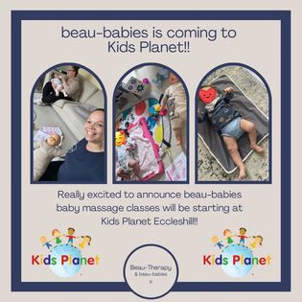
Weekly timetable to be confirmed – but if you’re interested in any of the above locations, please don’t hesitate to contact me on beautherapy.beaubabies@gmail.com

